Final Considerations part 1 and par 2

For the analysis part 1 weather trends data, most of the countries and lands in the world are locating in the northern hemisphere, which means the observed values in the northern hemisphere would more than in the southern.

And for the Temperature vs. City Latitude trend, most of the highest value are located close to 0 degree to +-20 degree, which are direct solar radiation area, Tropical ecosystems. The temperature will higher than other location. And the temperature will decrease as close as north pole and south pole.

The Latitude range is showing from -60 up to 80, the reason might be in Arctic circle, there are many people living here and have many countries such as Russia, Norway. But in Antarctic circle, there are only ocean and ice, not so many observatories are setup to receive the data.

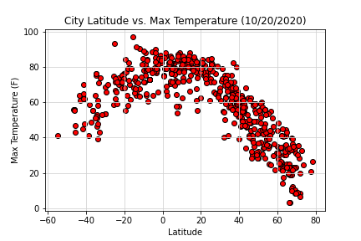

The trend of Humidity vs. Latitude shows above 60% of cities have more than 60% humidity, there are few cities have less than 40% humidity, the reason might be those cities are located around +-20 degree Latitude, which usually are desert or have harsh climate so there are not suitable for everyone living. And there are many small islands in Asia, the humidity will less than mainland Continental countries.

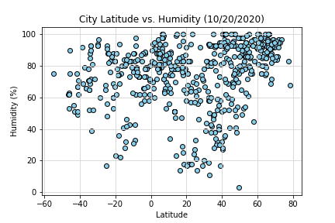

For the last trend of Wind Speed vs. Latitude, the most of land are located in the northern hemisphere, as well as the largest ocean “the Pacific” ,”the Atlantic”,” the Arctic Ocean”, which making the barometric change and cause the air convection, so the average wind speed will higher than in the southern.

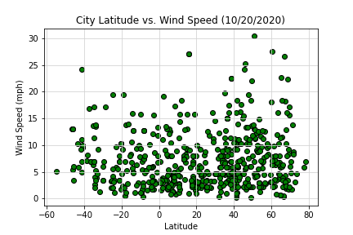

There is screenshot for part 2.

